AWS -Code Pipeline

Task : Deploy a simple Nginx application using AWS code commit and deploy & access via browser

Unable to create repository in free account hence used github repo

Created below files

1. buildspec.yml
2. Dockerfile
3. Index.html
4. nginx.conf

Created github connection to my repo

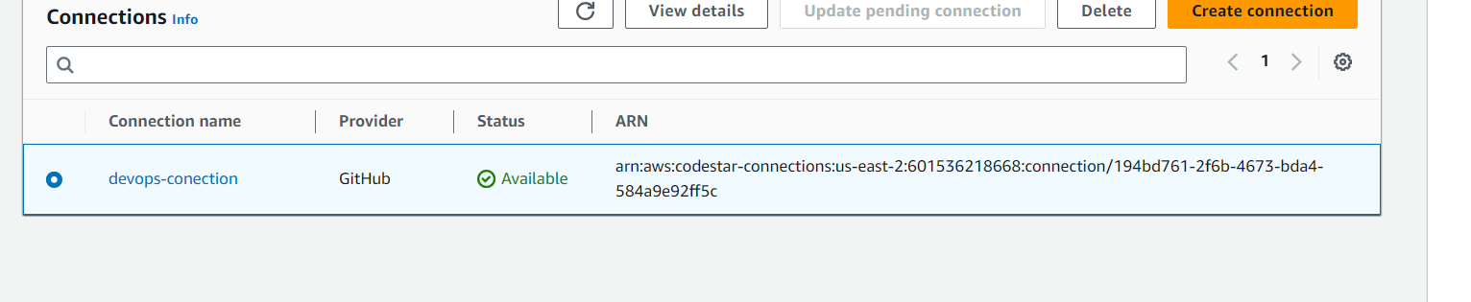

Create build projects

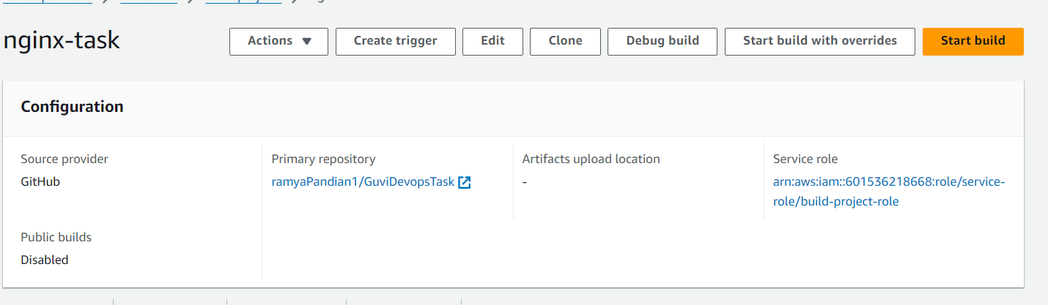

Buildspec file contains

Docker build command and push the image to docker hub

Run the project

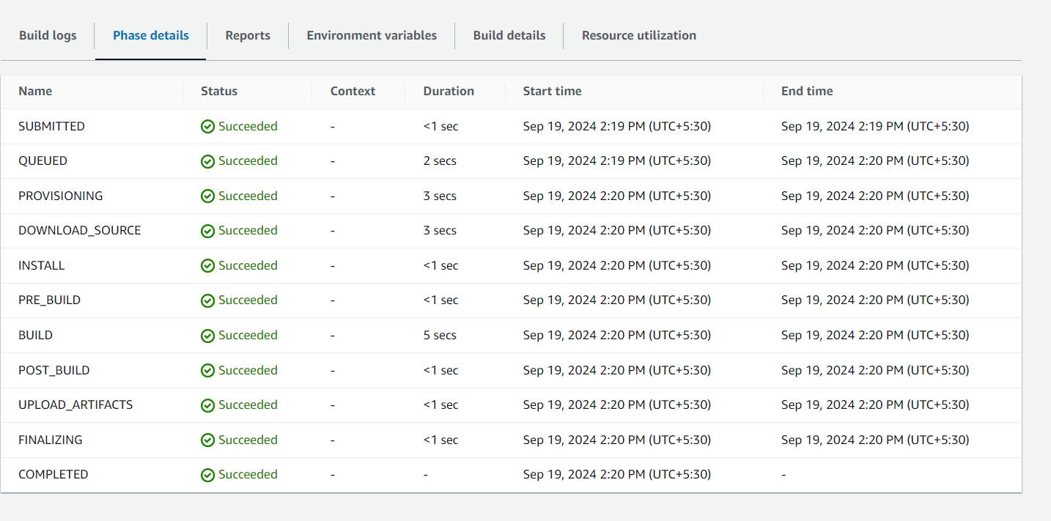

Image is pushed to docker hub



Launch an ec2 instance and install docker

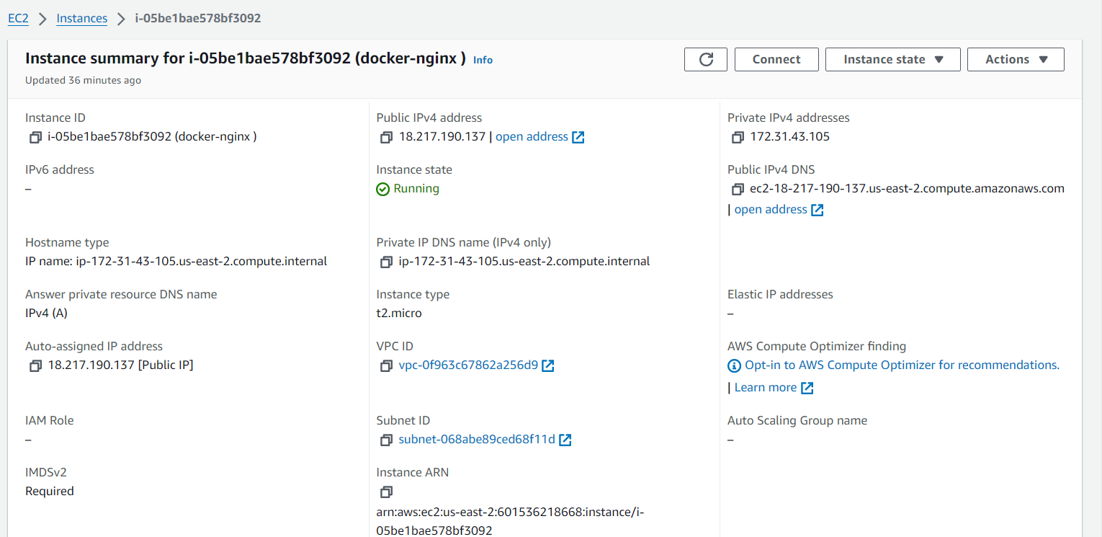

Docker pull and run the container

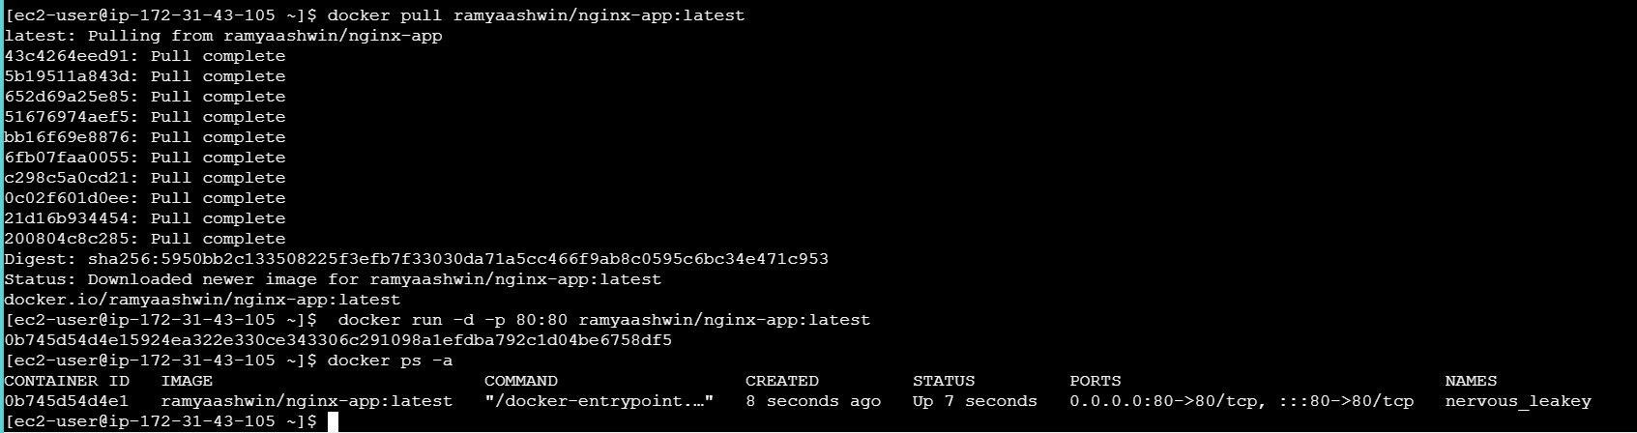

Access via browser

